Covid-19 Vaccinations - Project Proposal

Anitha Ganapathy, Keerthana Reddy Varakala, Saymon Mameza

Dr. Ahn  
D590: Data Visualization

Luddy School of Informatics, Computing and Engineering, Indiana University

28 June 2022

Abstract

The first case of SARS-CoV-2 virus was detected in Wuhan City, Hubei Province of China. Covid-19 was declared as a pandemic in March 2020 and since then, it's been more than 2 years. The quick widespread spread of the disease has affected the way of life in every aspect known to us. Many preventive measures have been undertaken by WHO and CDC to prevent and slow down transmission by providing details to the public about the disease itself and how it spreads. Much vaccine research was undertaken, and vaccines were developed within 12 months from the identification of the first case of the novel coronavirus. Many companies were in the race to create the vaccine for the virus and aid in bringing the epidemic to an end. The top companies being Johnson & Johnson, AstraZeneca, Moderna, BioNTech, Pfizer and Novavax to name a few. The vaccines created must satisfy the diversity in population, global access and provide immunity against the variants. Further research and trials are still ongoing to create a vaccine that can provide immunity against various symptoms of the novel coronavirus.

*Keywords:* COVID-19, SARS-CoV-2, types, vaccine, pandemic, coronavirus

Introduction

On December 31, 2019, a novel coronavirus disease caused by severe acute respiratory syndrome type 2 coronavirus (SARS-CoV-2) was first reported in China. On January 30, 2020, the World Health Organization (WHO) announced that the new coronavirus pneumonia epidemic was listed as a "public health emergency of international concern," and on February 11, the WHO officially named the disease as Coronavirus disease 2019 (COVID-19). This caused a widespread panic and uncertainty in the public globally. The spread of the virus was very quick and created an emergency and an urgency amongst the community of the scientists from around the world to design anti-SARS-CoV-2 vaccines. SARS-CoV2, the coronavirus responsible for COVID-19 is an RNA virus, and these viruses generally have a high mutation rate. Genetic instability has long been considered to represent a challenge to develop effective vaccines against RNA viruses.

The virus may gradually evolve into a seasonal low-level epidemic. Even if the virus can be completely eliminated from the population, the transmission mechanism from the host to the person is still unclear due to the population's general susceptibility. There is a risk of recurrence or periodic epidemics. Vaccines need to be administered as soon as possible. The union collaborations amongst the leaders of the world along with WHO and CDC provided major support to invent vaccines and perform trials to pass the stages of the vaccine approval. The vaccines for covid-19 are still being studied and re-invented and many trials are taking place currently for approvals.

Objectives and Question

[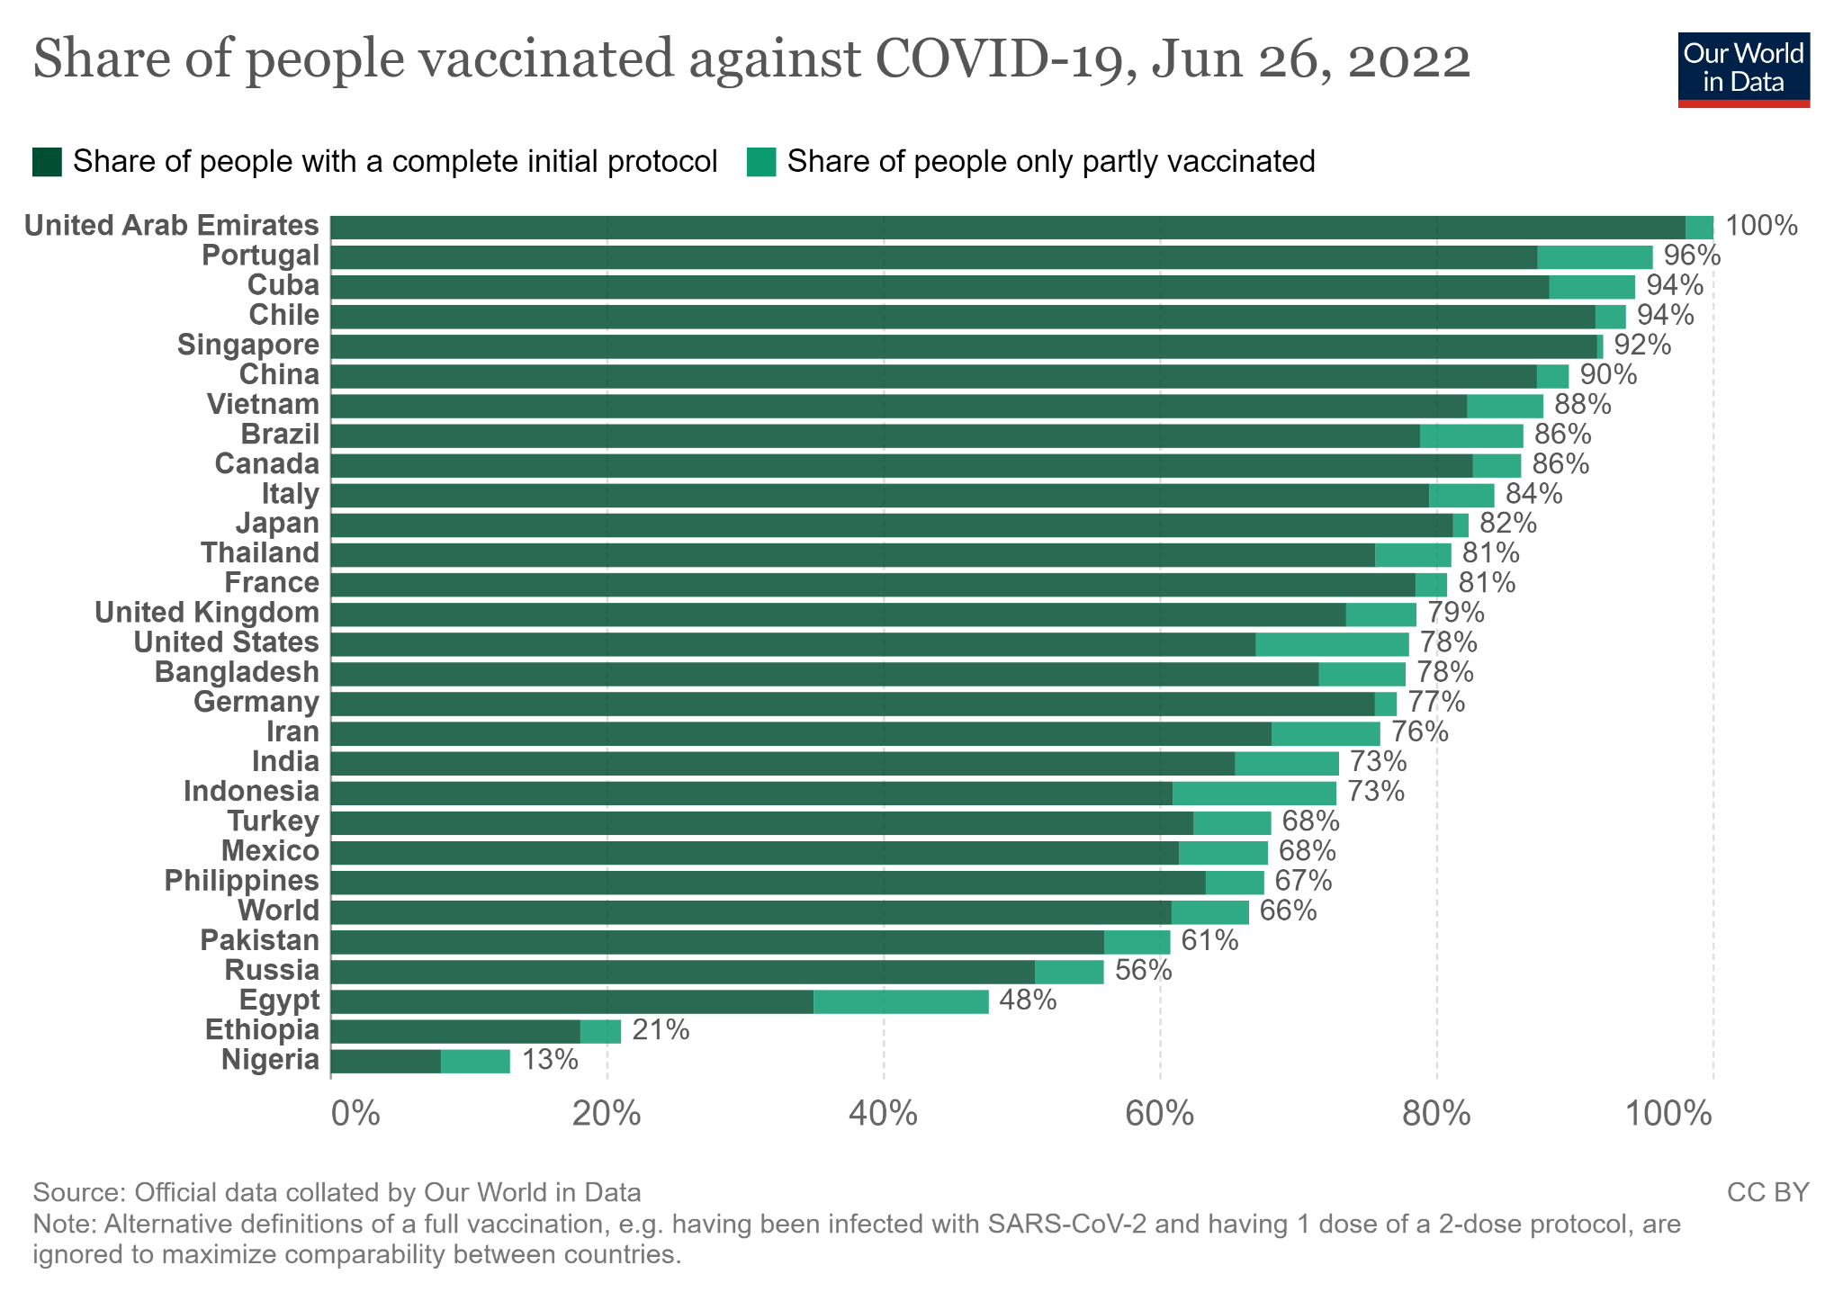](https://ourworldindata.org/covid-vaccinations)

Fig 1: Existing Visualization on Vaccination records in different countries.

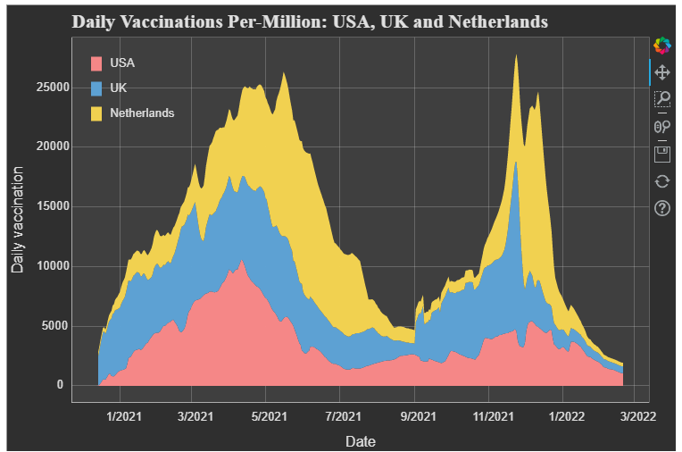

Fig 2: Existing Visualization about the daily vaccinations

Source: des., des. (2022). *Area plot*. Kaggle. Retrieved June 27, 2022, from https://www.kaggle.com/code/desalegngeb/bokeh-visualization-library-guide-for-beginners.

We want to show different kinds of visualizations in our project. Firstly, we would like to show an interactive map plot showing the total number of people vaccinated in a country throughout the world to see how many people in a particular country have been vaccinated.Then a map chart of animation showing the percentage of the population that got vaccinated inorder to know how much percentage of population of a particular country has been vaccinated.An interactive plot showing the vaccinations per month in different countries across the world to see how actively the vaccinations are given. A plot showing people vaccinated and people fully vaccinated per month to know the ratio of people getting booster dose. A plot showing the ratio of total booster and total vaccinations for each country in the world. A plot showing total vaccinations and people fully vaccinated in the world.An interactive map plot with states and different kinds of possible information across the USA. A plot for daily vaccinations vs Daily vaccinations per million.An interactive plot for date vs different kinds of information possible in states across the USA. An interactive plot for date vs different kinds of information possible in countries across the World. A heatmap for countries in the world and for the states in the USA with possible column values.

Datasets and Methods

For our project, we will be using three datasets from the same source, the CDC. All three datasets contain some null values. Therefore, we will need to do more analysis on why they contain blanks. The first dataset “Vaccinations by State” contains 6 columns and 34,021 rows. The columns are date, location, total vaccination, total distributed, people vaccinated, and daily vaccinations. The data types for the columns are date for date column, string for location, and the rest are integers.

The second dataset “Vaccination by Age-Group” contains 42,331 rows and 6 columns. The columns of the dataset are location, date, age-group, people vaccinated, people fully vaccinated, people with booster. The data types for the columns are date for date column, strings for location and age-group, and the rest are integers. The third dataset “Vaccination by Manufacturer” contains 4 columns and 39,888 rows. The columns are date, location, vaccine, and total vaccination. The data types are date for date column, string for vaccine and location, and integer for total vaccination.

Overall, the three datasets are excellent for our planned analysis. All of the visualization methods mentioned in the questions and objective sections are achievable. For example, creating an interactive map plot showing the total number of people vaccinated in a country throughout the world is achievable since we have vaccinations data for countries around the world. We can also create heat maps that progress by time since we have the date, country, and amount of vaccinations fields. We can also add an age group legend that shows the growth of vaccinations by country. Our main objective is to give a high-level overview of the data, and then try to dive deeper into the analysis. This way, we want to tell an effective story on what the data is trying to tell us.

References

Ritchie, H., Mathieu, E., Rodés-Guirao, L., Appel, C., Giattino, C., Ortiz-Ospina, E., Hasell, J., Macdonald, B., Beltekian, D., & Roser, M. (2020, March 5). *Coronavirus (COVID-19) vaccinations*. Our World in Data. Retrieved June 25, 2022, from https://ourworldindata.org/covid-vaccinations

*Top 10 companies leading the race of COVID-19 vaccine*. Intellizence. (2021, September 21). Retrieved June 25, 2022, from https://intellizence.com/insights/top-10-companies-leading-the-race-of-covid-19-vaccine/

World Health Organization. (n.d.). *Coronavirus*. World Health Organization. Retrieved June 25, 2022, from https://www.who.int/health-topics/coronavirus#tab=tab_1

World Health Organization. (n.d.). *Covid-19*. World Health Organization. Retrieved June 25, 2022, from https://www.who.int/emergencies/emergency-events/item/coronavirus-disease